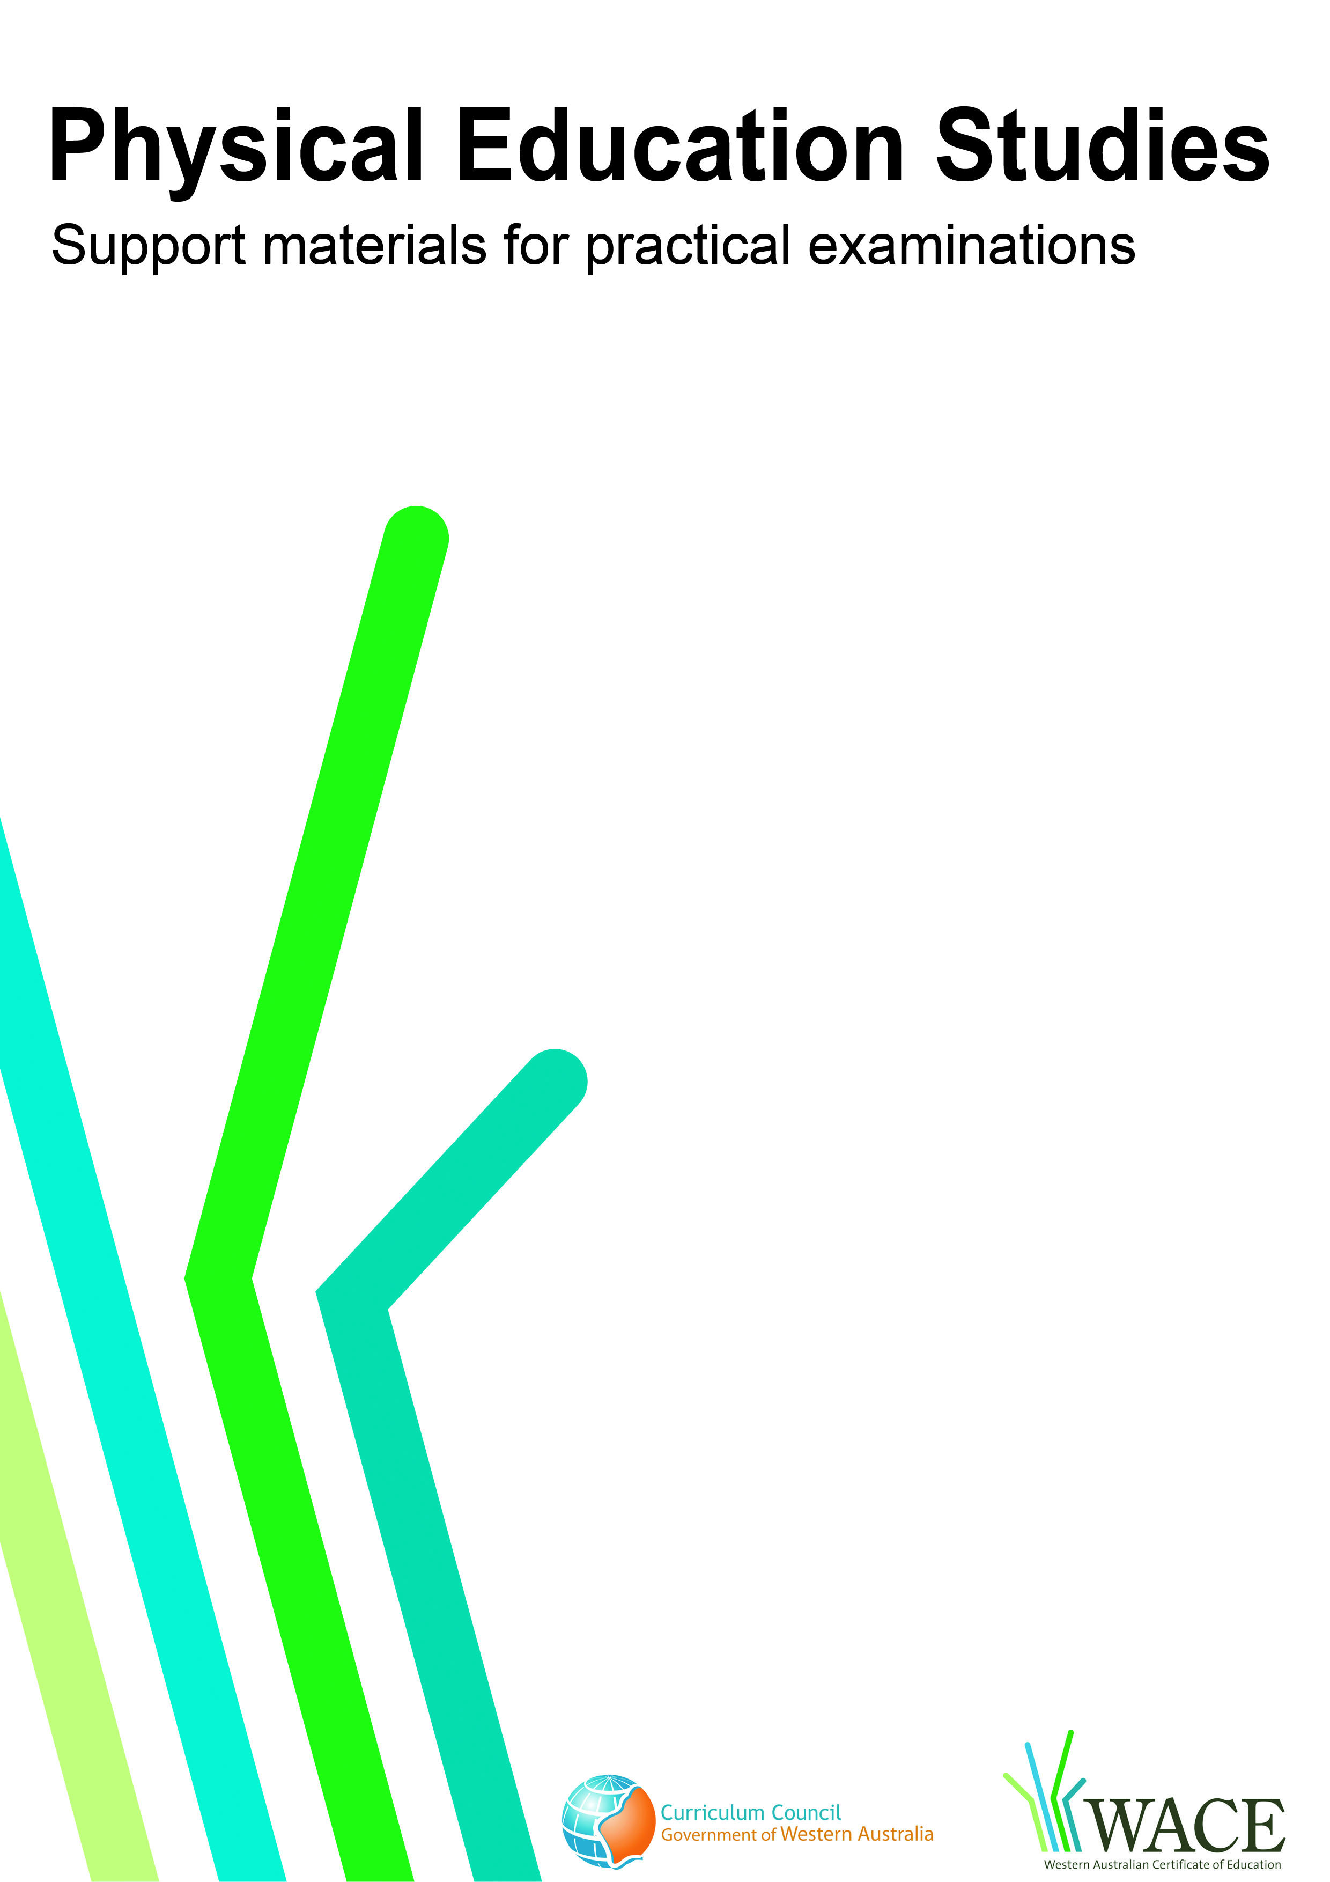

Touch Football

© Curriculum Council, 2011
This document—apart from any third party copyright material contained in it—may be freely copied, or communicated on an intranet, for non-commercial purposes by educational institutions, provided that it is not changed in any way and that the Curriculum Council is acknowledged as the copyright owner.
Copying or communication for any other purpose can be done only within the terms of the Copyright Act or by permission of the Curriculum Council.
Copying or communication of any third party copyright material contained in this document can be done only within the terms of the Copyright Act or by permission of the copyright owners.
Version 5
Introduction
The purpose of these materials is to support teachers and candidates in preparation for the Physical Education Studies practical examination.

Skills set for touch football
These materials outline the examinable skills set for touch football. Five (5) of the skills, selected by the examination panel, will be examined and these will be communicated to the candidates at the commencement of the examination.

Observation points
Observation points are provided for each skill in the skills set. They are provided for the purpose of teaching and coaching and are designed to assist examination candidates in their personal skill development.

Examination drills
The examination will contain a number of drills through which the selected skills will be assessed. These materials outline a number of drills indicative of the types of drills in which the candidates will participate during the examination and may form part of a teaching program.

Tactical framework
In the conditioned performance section of the examination, candidates will participate in a modified competitive situation, which will be based on some of the tactical problems in touch football. The tactical problems for the examination are outlined in the tactical framework and will be selected by the examination panel. The skills that provide the basis for the solutions to these tactical problems are also included in the framework.

In the conditioned performance section of the touch football examination, students will be assessed on the execution of skills, use of space, positioning and decision making that effectively solve the tactical problems presented by the modified competitive situation.

CONTENTS | PAGE NUMBER
Touch football skills set | 5
Skills set and observation points | 6
Touch football drills | 10
Drill descriptions | 11
Tactical framework | 29

Skill number | Name of skill | Page number
1 | Running pass | 6
2 | Lateral pass | 6
3 | Catch | 6
4 | Half pass (long ball) | 7
5 | Half pass (pop) | 7
6 | Effecting a touch – attacker (dump/roll ball) | 7
7 | Dummy pass | 8
8 | Evading side step | 8
9 | Spiral pass | 8
10 | Scoring a touchdown | 9
11 | Effecting a touch -defender | 9
12 | Scoop | 9

1. RUNNING PASS
Preparation | Execution | Conclusion
- Ball is held with two hands on either side with fingers spread and elbows slightly bent  - Body is balanced with the outside leg forward and the body turned towards the receiver  - Eyes are looking towards the target  - Ball is carried in front of the body | - Upper torso rotates to swing the ball across the front of the body  - Weight is transferred onto the foot closest to the target  - Velocity and angle of pass is appropriate to distance required  - Flexion of the wrists directs the ball towards the receiver | - Follow through is balanced with fingers pointed towards the receiver  - Ball travels backwards with a flat trajectory  - Ball is received by team-mate between the shoulders and waist  - Receiver is able to run onto the ball  - Player repositions and is available for a pass
2. LATERAL PASS
Preparation | Execution | Conclusion
- Ball is held with two hands on either side with fingers spread  - Body is balanced with the outside leg forward and the body turned towards the receiver  - Eyes are looking towards the target  - Ball is carried in front of the body | - Upper torso rotates to swing the ball across the front of the body  - Weight is transferred onto the foot closest to the target  - Velocity and angle of pass is appropriate to distance required  - Flexion of the wrists directs the ball towards the receiver | - Follow through is balanced with fingers pointed towards the receiver  - Ball travels backwards with a flat trajectory  - Ball is received by team-mate between the shoulders and waist  - Team mate is able to run onto the ball  - Player repositions and is available for a pass
3. CATCH
Preparation | Execution | Conclusion
- Body is balanced with feet shoulder width apart  - Arms slightly flexed with palms facing inwards at waist level  - Body position is adjusted relative to player passing the ball and flight of the ball  - Flight path of the ball is followed all the way into the hands | - Hands are extended with fingers spread and pointing in the direction of the ball  - Fingers and elbows flex on impact to absorb force  - Ball is caught towards the mid-line of the body | - Ball is guided into control with a ‘giving’ action  - The next pass or movement is anticipated

4. HALF PASS (long ball)
Preparation | Execution | Conclusion
- Outside foot is placed near the ball  - Ball is held with two hands on either side with fingers spread and elbows slightly bent  - The player looks at the receiver after securing the ball  - Base of support is wide and balanced with inside foot towards the receiver | - A single movement is used to swing the ball from the ground  - Upper torso rotates to swing the ball across the front of the body  - Velocity and angle of pass is appropriate to the distance required  - Weight is transferred onto the foot closest to the target | - Follow through is balanced with fingers pointed towards the receiver  - Ball travels backwards and spirals with a flat trajectory  - Ball is received by team-mate between the shoulders and waist  - Team-mate is able to run onto the ball  - Player repositions and is available for a pass
5. HALF PASS (pop)
Preparation | Execution | Conclusion
- Base of support is wide and the ball is swung across the body  - Outside foot is positioned near the ball  - Inside foot is facing towards the receiver  - Hips and knees flex to allow for pick-up of the ball | - The ball is secured with both hands  - Relative position of team-mate receiving the pass is monitored  - Ball is directed through flexion of the wrists  - Ball is flicked slightly backwards into space for the oncoming runner  - Velocity and angle of pass is appropriate to the distance required | - Follow through is balanced with fingers pointed towards the receiver  - Ball travels backwards  - Ball floats or ‘hangs’ with no spin  - Ball is received by team-mate between the shoulders and waist  - Team-mate is able to run onto the ball  - Player repositions and is available for a pass
6. EFFECTING A TOUCH – ATTACKER (dump/roll ball)
Preparation | Execution | Conclusion
- Balance is maintained by lowering body position  - Body is positioned to one side of the defender  - The player decelerates in anticipation  - Eyes are focused on the hips of the defender | - Knees and the hips flex to lower the base of support  - Ball is controlled in a secure position  - Hand nearest the defender is extended to initiate the touch on opponent with minimal force  - Touch is effected at hip height | - Ball is controlled to the ground just in front of or between the feet that are parallel to the sidelines  - Player steps forward and square over the ball  - Player repositions and is available for a pass

7. DUMMY PASS
Preparation | Execution | Conclusion
- Ball is held with two hands on either side and with fingers spread  - Body is balanced with outside leg forward and body turned towards the receiver  - Eyes are looking towards the target and peripheral vision is used to demonstrate awareness of opposition  - Ball is carried in front of the body | - Ball is swung across the front of the body  - Full range of motion of the upper torso is used to achieve deception  - Arms are fully extended as if the ball is going to be passed  - Acceleration occurs as the dummy is completed | - Ball is held firmly and returned to normal carrying position  - Opponent is successfully deceived  - Player shows awareness of further options
8. EVADING SIDE STEP
Preparation | Execution | Conclusion
- Balance is maintained during the run  - Control of the ball is maintained  - A slight step to the side establishes a wider base of support and forces defender to commit to a lateral movement | - Body weight is transferred towards the stepping leg  - The body feints towards the stepping side  - Knee is extended to achieve a push off the ball of the foot in the opposite direction  - Shoulders are rotated slightly away from opponent | - Acceleration is away from the opponent at a new angle  - Defender is out of position  - Player shows awareness of further options
9. SPIRAL PASS
Preparation | Execution | Conclusion
- Outside-hand is nearer to the rear of the ball whilst the inside hand is near the front  - Body is balanced with outside leg forward and body turned towards the receiver  - Eyes are looking towards the target | - Inside leg steps towards the target  - Front end of the ball is pointed slightly higher towards the receiver and swung across the front of the body with two hands  - As the ball is delivered the outside hand rotates over the ball to impart spin  - Velocity and angle of pass is appropriate to the distance required  - Wrist flexion directs ball backwards towards the receiver | - Follow through is balanced with fingers pointing towards the receiver  - Ball travels with a flat trajectory  - Ball is received by team-mate between the shoulders and waist  - Team-mate is able to run onto the ball  - Player repositions and is available for a pass

10. SCORING A TOUCHDOWN
Preparation | Execution | Conclusion
- Location of score line is identified  - Acceleration towards the score line  - Body leans forward in preparation to lower the body  - Knee and hip flexion lowers the body | - Arms and body stretch downwards reaching on or beyond the score line  - Ball is held securely in one or two hands | - Downward pressure is applied to the ball once on or over the score line  - Balance is maintained throughout
11. EFFECTING A TOUCH – DEFENDER
Preparation | Execution | Conclusion
- Balance is maintained by lowering body position  - Body is positioned in front of the attacker  - Acceleration is towards attacking player  - Eyes are focused on the lower trunk of the attacker | - Hand nearest the attacker is extended to effect the touch on opponent with minimal force  - Touch is effected at shoulder height | - Defender regains balance and retreats to onside position
12. SCOOP
Preparation | Execution | Conclusion
- Outside foot is positioned side-on and near the ball  - Hips and knees flex to allow for low pick up  - Eyes are focused on the ball | - Balance and speed are maintained throughout  - Arms swing across the body to scoop up the ball in one hand  - Hands are positioned to secure the ball and lift it off the ground | - Extend through the hips to get back to upright position  - Player shows awareness of further options

Drill number |  | Page number
1 | Catch, lateral pass, spiral pass | 11
2 | Scoring a touchdown, effecting a touch – defender, evasion | 12
3 | Half pass (long ball) | 13
4 | Half pass (pop) | 14
5 | Scoop, effect the touch – attacker (dump/roll ball) | 15
6 | Scoop, evading a side step, scoring a touchdown | 16
7 | Effect the touch – attacker (dump/roll ball), half pass (long ball), evading a side step | 17
8 | Catch, running pass | 18
9 | Catch, half pass (pop) | 19
10 | Catch, lateral pass, spiral pass | 20
11 | Effecting a touch – attacker (dump/roll ball), effecting touch – defender, scoring a touchdown | 21
12 | Scoop, evading a side step, scoring a touchdown | 22
13 | Catch, running pass, dummy pass | 23
14 | Catch, running pass, lateral pass, spiral pass, scoring a touchdown | 24
15 | Catch, running pass, scoring a touchdown | 25
16 | Scoop, running pass, effect the touch – attacker (dump/roll ball) lateral pass | 26
17 | Effect the touch – attacker (dump/roll ball), half pass (pop), catch | 27
18 | Catch, lateral pass, running pass, dummy pass, effect the touch – attacker (dump/roll ball), effecting touch –defender, scoring a touchdown, half pass (pop), scoop | 28

These drills are indicative of the types of drills in which the candidates will participate during the examination and may form part of a teaching program.
Drill 1: Catch, lateral pass, spiral pass

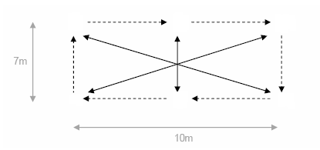
X₄
X₃
X₅
X₁
X₂
X₆

Key | X = player | → = player movement
 | O = feeder | ----- = ball movement
 | = marker

Drill description
- Ball is to be passed around the outside of the rectangle.
- Players on the corners (X₁, X₂, X₃ and X₄) must run diagonally across the square to the opposite corner once they have passed the ball.
- Players in the middle of each side (X₅ and X₆) must run across the square once they have passed the ball.
- Change direction to test other passing side.

Drill 2: Scoring a touchdown, effecting a touch – defender, evasion

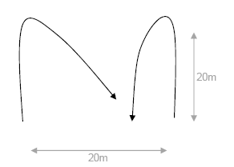
X₁
X₂

Key | X = player | → = player movement
 | O = feeder | ----- = ball movement
 | = marker

Drill description
- On the command ‘go’, the attacker (X₂) (with the ball) must run around marker and back to score a touchdown before the defender (X₁) effects a touch.
- The defender (X₁) should effect the touch from the side or behind.

Drill 3: Half pass (long ball)
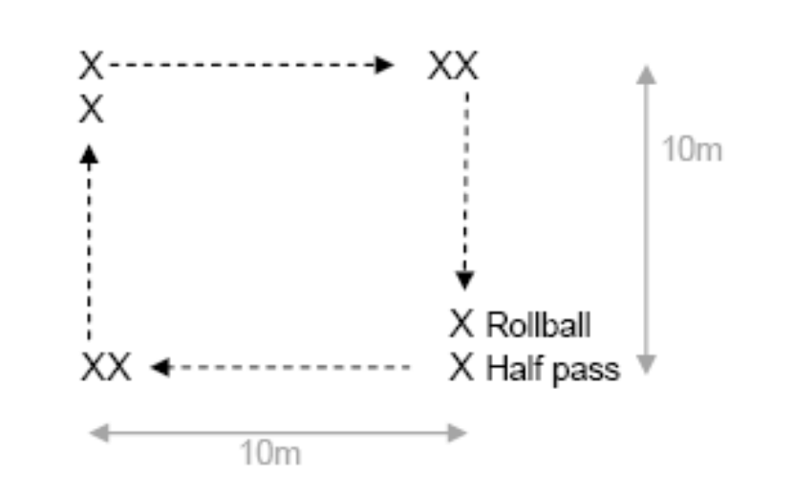

Key | X = player | → = player movement
 | O = feeder | ----- = ball movement
 | = marker

Drill description
- Players work in pairs in rollball and acting half positions.
- Rollball is performed, then ball is passed to the next pair off the ground from acting half position.
- Process is repeated and ball is passed around the square.
- Players stay in pairs but swap positions.
- Reverse direction to test the other passing side.

Drill 4: Half pass (pop)
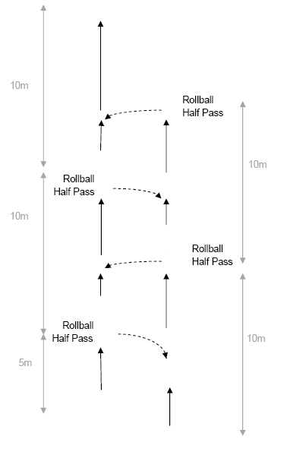
X₁
X₂
X₃
X₄
X₁
X₂
X₁
X₂
X₄
X₃
X₃
X₄
X₃
X₄

Key | X = player | → = player movement
 | O = feeder | ----- = ball movement
 | = marker

Drill description
- Players work in pairs in rollball and acting half positions.
- X₁ starts with the ball, runs to first marker and performs rollball.
- X₂ runs into acting half position and sends half pass to X₃ who receives the ball on the run.
- X₃ continues running to the first marker and performs rollball.
- X₄ sends half pass to X₁ who receives the ball on the run.
- Continue process to end marker.
- Change positions on return run.

Drill 5: Scoop, effect the touch – attacker (dump/roll ball)

X₁
5m
X₂
D
scoop
scoop

Key | X = player | → = player movement
 | O = feeder | ----- = ball movement
 | = marker

Drill description
- X₁ runs from the first marker, picks up the ball at the second marker (scoop), passes to X₂ who effects the touch on a stationary defender and performs rollball at the third marker then runs through.
- Repeat the process at the next two markers.
- After turning at the last marker, repeat the same process using the non preferred hand.
- Upon completion X₁ and X₂ swam positions and repeat.

Drill 6: Scoop, evading a side step, scoring a touchdown
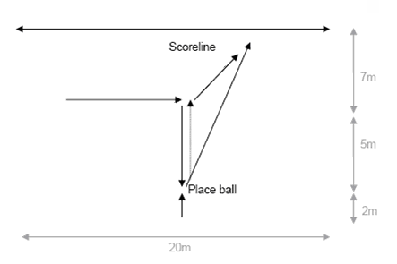

X₁
X₂
X₁
X₂

Key | X = player | → = player movement
 | O = feeder | ----- = ball movement
 | = marker

Drill description
- Defender (X₂) moves sideways around the first marker, then forwards to place ball on the ground beside the second marker and then begins retreating backwards to the first marker.
- Attacker (X₁) scoops up the ball, accelerates/steps in either direction past the defender.
- Once defender retreats 5m, they can turn and chase the attacker to prevent them from scoring.

Note: Defender cannot change direction until she/he has retreated 5m.

Drill 7: Effect the touch – attacker (dump/roll ball), half pass (long ball), evading a side step
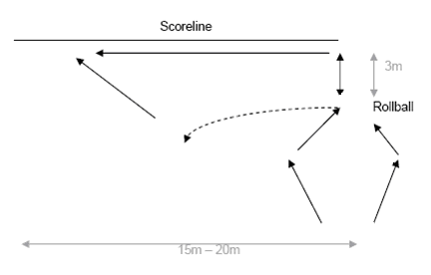

X₁
X₂
X₂
X₁
X₄
5m
X₃
X₄

Key | X = player | → = player movement
 | O = feeder | ----- = ball movement
 | = marker

Drill description
- X₂ (with the ball) and X₁ run around markers. X₂ effects the touch and dumps on X₄ (the defender) and X₁ goes into acting half.
- X₄ retreats 5m to the marker.
- X₁ passes long ball (10m) from the ground to X₃.
- X₃ receives the ball on the run and attempts to score over the scoreline without getting touched.
- X₄ must try to effect the touch on X₃.

Drill 8: Catch, running pass

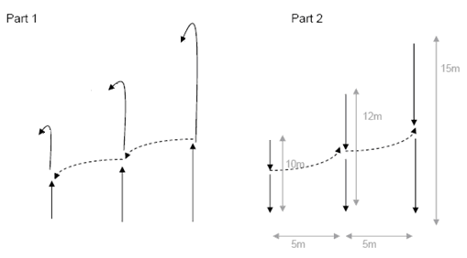
X₁
X₂
X₃
X₁
X₂
X₃
X₁
X₂
X₃
X
X
X

Key | X = player | → = player movement
 | O = feeder | ----- = ball movement
 | = marker

Drill description
Part 1
- Ball starts at X₃.
- X₃ taps the ball, runs with the ball a few metres then passes to X₂ who receives the ball on the run, runs a few metres and passes the ball to X₁.
- All players run around their end markers (X₁ still has the ball).
Part 2
- On return, X₁ passes the ball to X₂ on the run, who runs a few metres and passes off to X₃.
- Reverse the drill to test other passing side.

Drill 9: Catch, half pass (pop)

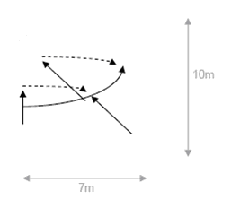
X₃
X₂
X₁
X₄
X₁
X₂

Key | X = player | → = player movement
 | O = feeder | ----- = ball movement
 | = marker

Drill description
- X₁ starts with the ball, runs a few metres and passes to X₂ who receives the ball on the run.
- X₂ then accelerates on an angle towards the area where the pass came from.
- X₁ accelerates behind X₂ in a loop.
- X₂ passes the ball to X₁ who receives the ball on the run in the gap outside X₂.
- Pass off to next pair to perform wrap on return run.

Variation
- X₁ starts with the ball, runs a few metres and passes to X₂ who receives the ball on the run.
- X₂ then accelerates on an angle between defenders (X₃ and X₄) to draw X₄.
- X₁ accelerates behind X₂ in a loop.
- X₂ passes the ball to X₁ who receives the ball on the run in the gap outside X₄ and scores.

Drill 10: Catch, lateral pass, spiral pass

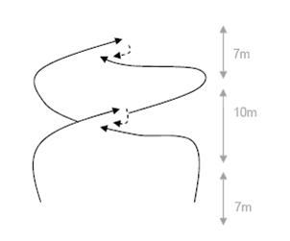
X₃
X₄
X₁
X₂

Key | X = player | → = player movement
 | O = feeder | ----- = ball movement
 | = marker

Drill description
- X₁ starts with the ball and runs past the first marker, then on an angle diagonally towards the second marker.
- X₂ runs towards the first marker, then diagonally towards the second marker, ensuring about two metres distance between X₁ and X₂.
- X₂ receives the pass from X₁ who has waited until X₂ is directly behind them before rotating their body in the direction of X₂.
- X₂ straightens towards the third marker and repeats the above process, passing to X_{1.}

Variation
- X₁ starts with the ball and runs past the first marker, then on an angle diagonally, taking on defender X₃ on the outside.
- X₃ starts at the edge of the grid and attempts to touch the ball carrier.
- X₂ runs straight, then diagonally to accept the pass from X₁.
- X₂ receives pass from X₁ who has waited until X₂ is directly behind them before rotating their body in the direction of X₂.
- X₂ straightens and scores over the end line.

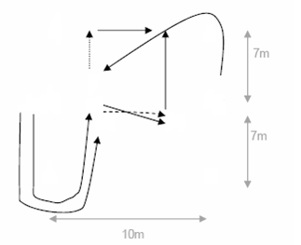
Drill 11: Effecting a touch – attacker (dump/roll ball), effecting touch – defender, scoring a touchdown

X₃
X₃
X₁
X₂
X₂
X₁
X₂

Key | X = player | → = player movement
 | O = feeder | ----- = ball movement
 | = marker

Drill description
- X₂ runs with the ball and positions body to one side of defender (X₃).
- Defender runs toward attacker (X₂), decelerating, and remaining balanced to effect the touch.
- X₂ and X₃ effect the touch, X₂ then performs a rollball for X₁ then splits.
- X₃ retreats backwards 5m.
- X₁ passes off the ground to X₂ who attempts to score a touchdown.
- X₃ attempts to effect a touch on X₂ to stop the touchdown from being scored.

Drill 12: Scoop, evading a side step, scoring a touchdown

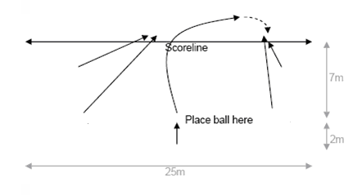
X₃
X₆
X₅
X₂
X₁
X₄

Key | X = player | → = player movement
 | O = feeder | ----- = ball movement
 | = marker

Drill description
- Ball is placed beside the marker and X₄ (defender) lies face down on the ground.
- X₁ (attacker) scoops the ball and runs over the score line looking for attacking support.
- When X₁ has touched the ball, X₄ can get up off the ground and chase X₁.
- X₂ and X₃ (attackers) must try and provide a scoring option for X₁ to pass to and score.
- X₅ and X₆ (defenders) must chase their opponents and stop them from scoring.

Drill 13: Catch, running pass, dummy pass

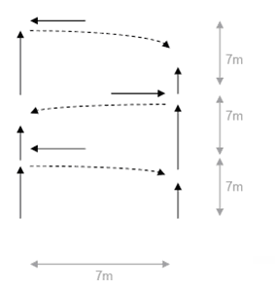
X₅
X₁
X
X₂
X
X₃
X₄

Key | X = player | → = player movement
 | O = feeder | ----- = ball movement
 | = marker

Drill description
- Players work in pairs to beat defenders (X₃–X₅).
- Defenders can only move sideways, not forwards or backwards.
- X₁ must draw defender then pass to X₂ who is running in an onside position.
- X₂ then runs and draws second defender then passes to X₁ who is running in an onside position (repeat process).
- If defender does not commit, attacker can throw a ‘dummy’ and continue to next marker without passing.

Drill 14: Catch, running pass, lateral pass, spiral pass, scoring a touchdown

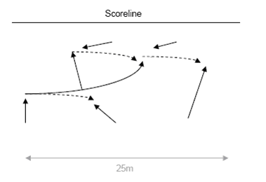
X₄
X₅
X₆
X₁
X₂
X₃
X₁
X₃
X₂

Key | X = player | → = player movement
 | O = feeder | ----- = ball movement
 | = marker

Drill description
- X₁ (attacker) runs a few metres with the ball then passes to X₂ (attacker) who receives the ball on the run.
- X₂ then straightens into the gap between defenders X₄ and X₅, commits X₅, then passes (appropriate pass) to X₁ who is straightening into gap between defenders X₅ and X₆.
- X₁ to score or draw X₆ and pass to X₃ (attacker) hitting outside gap.

Drill 15: Catch, running pass, scoring a touchdown
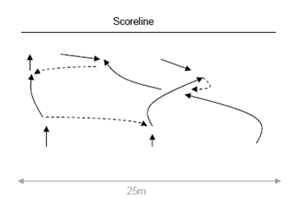

X₁
X₂
X₃
X₁
X₄
X₃
X₅
X₆
X₂

Key | X = player | → = player movement
 | O = feeder | ----- = ball movement
 | = marker

Drill description
- X₁ runs forward with the ball and passes off to X₂ who receives the ball on the run.
- X₂ runs straight to draw the defender X₅, and then accelerates on an angle between defenders X₅ and X₆.
- X₃ runs straight, then on an angle to receive the ball behind X₂, then accelerates on the angle between defenders X₄ and X₅.
- X₃ can score or draw defender X₄ and then pass off to X₁ who scores the touchdown.

Drill 16: Scoop, running pass, effect the touch – attacker (dump/roll ball) lateral pass

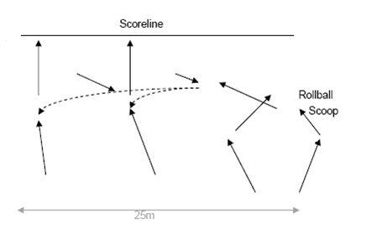
X₅
X₆
X₇
X₄
X₃
X₄
X₃
X₁
X₂
X₁
X₂
X₄

Key | X = player | → = player movement
 | O = feeder | ----- = ball movement
 | = marker

Drill description
- Attackers X₃ (with the ball) and X₄ run around the markers. X₃ dumps on X₇ (defender) and X₄ goes into acting half.
- X₄ scoops up ball and runs on angle at gap between defenders X₆ and X₇.
- X₄ must draw X₆ then pass to X₂ or X₁ depending on the reaction of X₅ (i.e. if X₅ goes to X₂, X₄ throws spiral pass to X₁. Alternatively if X₅ does not go towards X₂, X₄ needs to throw short pass to X₂).
- X₁ and X₂ need to be running hard and from depth at the gaps in front of them to assist X₄’s decision-making process.

Drill 17: Effect the touch – attacker (dump/roll ball), half pass (pop), catch
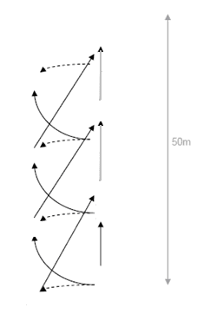
X₃
X₂
X₁
X₃
X₂
X₄
X₃
X₃
X₄
X₂
X₁
X₄
X₂
X₁
X₁

Key | X = player | → = player movement
 | O = feeder | ----- = ball movement
 | = marker

Drill description
- Players work in teams of three (X₁, X₂ and X₃) plus one defender (X₄).
- X₁ performs a rollball at the first marker, X₂ gives a half pass to X₃ who receives the ball on the run and hits angle toward X₄.
- X₃ effects the touch on X₄ (who retreats backwards to the next marker) and performs rollball.
- X₁ moves into acting half and passes the ball to X₂ who is running from first off position.
- Repeat above process for 3-4 markers.

Drill 18: Catch, lateral pass, running pass, dummy pass, effect the touch – attacker (dump/roll ball), effecting touch – defender, scoring a touchdown, half pass (pop), scoop
15m
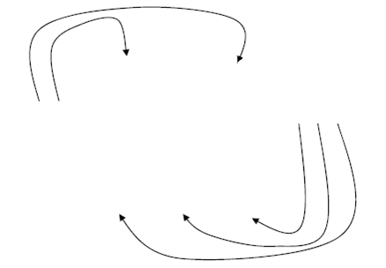
15m

X₂
X₁
X₃
X₁
X₂
X₃
X₄ X₅
X₄
X₅

X₅

Key | X = player | → = player movement
 | O = feeder | ----- = ball movement
 | = marker

Drill description
- At the same time, two defenders (X₄ and X₅) run around the end marker and into the grid and three attackers (X₁, X₂, X₃) (one with the ball) run around the opposite end marker and into the grid.
- The attackers must then draw and pass in an attempt to score over the defenders’ scoreline.
- The defenders must communicate and attempt to stop the attacking team from scoring by making a touch, forcing a dropped ball or intercepting a pass.
Progression 1: add ‘one touch’ to the game.
- Players enter the grid (as above) and the attacking team has one touch to use in order to score.
- Defenders must effect the touch and retreat 5m (or to the scoreline) as per game rules.
Progression 2: 4 on 3
- As per above, but four attackers and three defenders enter the grid.
- Increase width from 15m to 20m.

Progression 3: 4 on 3 plus ‘one touch’
- As per progression 1 with four attackers and three defenders.

Progression 4: 4 on 4 plus ‘3 touches’
- Teams of four attack and defend for three touches.
- Increase width from 20m to 30m.
Touch Football tactical framework

Tactical Problems | Off-the-ball skills | On-the-ball skills
SCORING (OFFENSE)
Maintaining possession of the ball | - Support- running with the ball carrier | - Running with the ball  - Effective passing – travelling backwards (left to right, right to left, long ball, short ball, pop ball)  - Effecting a mistake free roll ball
Line Attack  Rucking towards the line | - Width  - Execute set plays  - Set behind the ball carrier  - Positioning in space (running holes)  - Lateral movement (position adjustment)  - Width  - Execute set plays  - Set behind the ball carrier  - Positioning in space (running holes)  - Lateral movement (position adjustment)  - Timing of run to take flat pass from acting half | - Drawing or moving a defender  - Running into space  - Scoring a touchdown  - Effective roll balls  - Execute set plays  - Good positioning of acting half  - Diving to score  - Drawing a defender  - Running forward in possession  - Running onto the ball  - Scoring a touchdown  - Effective roll balls  - Execute set plays  - Good positioning of acting half  - Diving to score
PREVENTING SCORING (DEFENCE)
Line Defence  Ruck Defence | - Reducing space  - Protecting short sides  - Communication  - Moving forwards at a slower pace  - Understanding of basic policies i.e winger never makes a touch  - Reducing space  - Protecting short sides  - Communication  - Setting early/getting onside to prepare to shoot up  - Understanding of basic policies i.e winger never makes a touch | - Get in front of the ball  - Two handed touches  - Retreat quickly  - Protecting short sides  - Diving touch  - Taking the tap  - Communication  - Get in front of the ball  - Two handed touches  - Retreat quickly  - Attempt to shoot up in order to keep the ball as close to own score line as possible  - Communication  - Protecting short sides  - Diving touch  - Taking the tap
RESTARTING PLAY
After a penalty, roll ball, or touch down | - Width  - Prepare for set plays  - Set behind ball carrier  - Communication | - Correct tap or roll ball  - Prepare for set plays  - Communicate

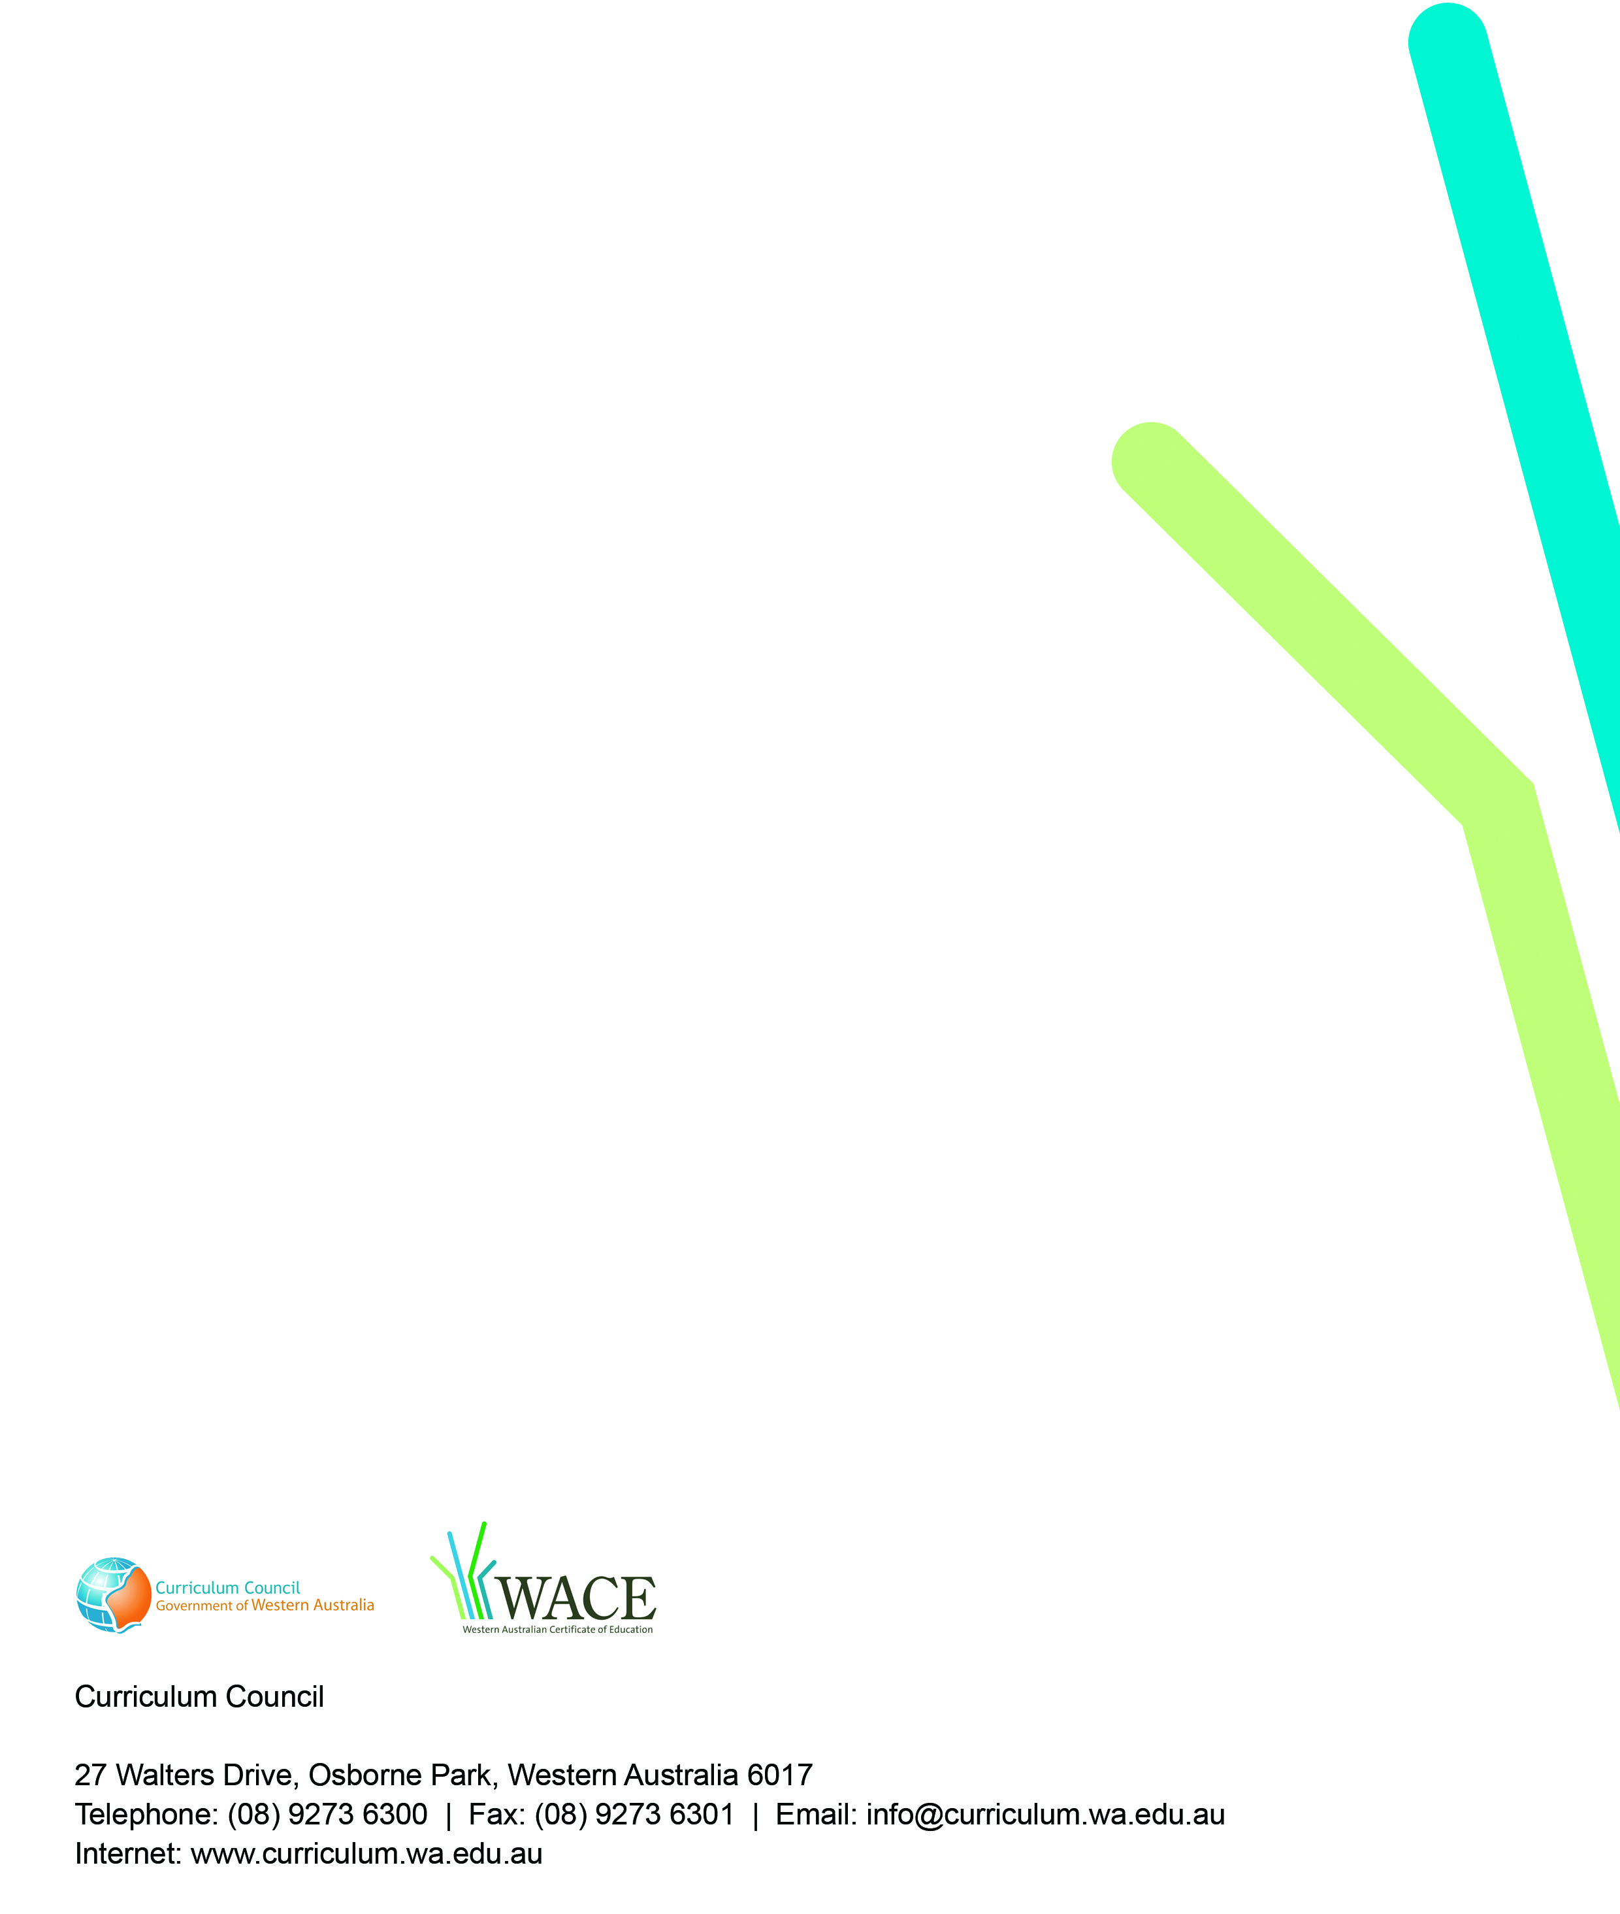
TRIM: 2009/8142[v3]

